Name_________________________________ Period _____________ Date ________________



**Lesson 1: What is Weather?**Temperature is one aspect of weather. Temperature is a measure of the hotness or coldness of the environment. In this lesson, you'll note and record temperature over many 30 year periods.

**Doing the Science**

1. Start the Weather simulation.

2. Each square on the Climate Change Calculator represents a temperature difference of 0.1 ºF from the normal average temperature in a given area over a one-year period. A red icon indicates an increase in temperature of 0.1 ºF. A blue icon indicates a decrease in temperature of 0.1 ºF. For instance, if the normal average yearly temperature for an area was 70.0 ºF, one red square would indicate that the average temperature for that one-year period was 0.1 ºF higher than normal or 70.1 ºF.

3, Click the "Spin" button. Record your data in the graph below.

4. Repeat the spin and record data process for a total of 30 spins.

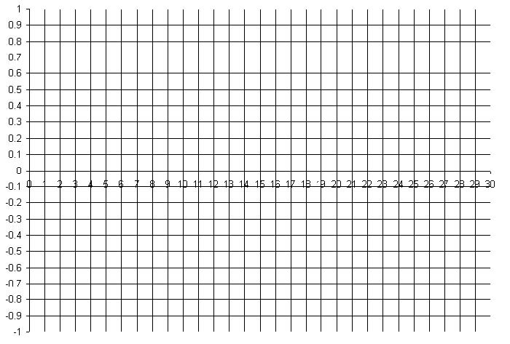

Number of Spins

Temperature difference from average yearly temperature (in °F.)

**Do You Understand?**

1. How many total years of weather data did you collect in this experiment? Did the temperature remain constant over that time period?
2. How did the number of days above an average temperature difference of “0” compare to the number of days below the average of “0”?